Orillia Secondary School Library

MLA Cheat Sheet #1

This sheet will assist you with integrating in-text citations
→ Basic style of using MLA in an essay or report
→ Paraphrasing/Summarizing
→ Short quotations
→ Long quotations

Using MLA the basics

In-text citation capitalization, quotation marks, and italics
- Always capitalize proper nouns, including author names and initials: D. Jones.
- If you refer to the title of a source within your paper or in your Works Cited Page, capitalize all words that are four letters long or greater within the title of a source: Permanence and Change. Exceptions apply to short words that are verbs, nouns, pronouns, adjectives, and adverbs: Writing New Media, There is Nothing Left to Lose.
- When capitalizing titles, capitalize both words in a hyphenated compound word: Natural-Born Cyborgs.
- Capitalize the first word after a dash or colon: "Defining Film Rhetoric: The Case of Hitchcock's Vertigo."
- Italicize the titles of longer works such as books, edited collections, movies, television series, documentaries, or albums: The Closing of the American Mind; The Wizard of Oz; Friends.
- Put quotation marks around the titles of shorter works such as journal articles, articles from edited collections, television series episodes, and song titles: "Multimedia Narration: Constructing Possible Worlds;" "The One Where Chandler Can't Cry."

Summarizing or Paraphrasing

If you are summarizing or paraphrasing an idea from another work, MLA guidelines require that you make reference to the author’s last name and page number. If making reference to the author in the summary, you only need to include the page number in parentheses. Otherwise, the author’s last name and page number should both appear in parentheses.

Examples:

Wordsworth extensively explored the role of emotion in the creative process (263).
MLA style is a difficult citation format for first-time learners, which is why it is extremely important that they refer to the MLA formatting materials provided to them (Lester 46-47).

Short quotations
If you are directly quoting from a work, you will need to include the author and page number(s). The author's name may appear either in the sentence itself or in parentheses following the quotation, but the page number(s) should always appear in the parentheses, not in the text of your sentence.
Examples:
Wordsworth stated that Romantic poetry was marked by a "spontaneous overflow of powerful feelings" (263).
Romantic poetry is characterized by the "spontaneous overflow of powerful feelings" (Wordsworth 263).

Long quotations
For quotations that are more than four lines of prose or three lines of verse, place quotations in a free-standing block of text and omit quotation marks. Start the quotation on a new line, with the entire quotation indented ½ inch from the left margin using the TAB key, while maintaining double-spacing. Your parenthetical citation should come after the closing punctuation mark. When quoting verse, maintain original line breaks. (You should maintain double-spacing throughout your essay.)
Example:
Nelly Dean treats Heathcliff poorly and dehumanizes him throughout her narration:
They entirely refused to have it in bed with them, or even in their room, and I had no more sense, so, I put it on the landing of the stairs, hoping it would be gone on the morrow. By chance, or else attracted by hearing his voice, it crept to Mr. Earnshaw's door, and there he found it on quitting his chamber. Inquiries were made as to how it got there; I was obliged to confess, and in recompense for my cowardice and inhumanity was sent out of the house. (Bronte 78)
Notice the indent when the quote is first started. There are also no quotation marks for the quotation.

Purdue Writing Lab. “MLA Formatting Quotations // Purdue Writing Lab.” Purdue Writing Lab, https://owl.purdue.edu/owl/research_and_citation/mla_style/mla_formatting_and_style_guide/mla_formatting_quotations.html. Accessed 23 October 2019.
Orillia Secondary School Library

MLA Cheat Sheet #2 -Title Page and Works Cited

This sheet will assist you with your MLA Title page and Works Cited page.

Basic Rules for MLA Title Page
- Do not make a title page for your paper unless specifically requested.
- In the upper left-hand corner of the first page, list your name, your instructor's name, the course, and the date. Again, be sure to use double-spaced text.
- Double space again and center the title. Do not underline, italicize, or place your title in quotation marks. Write the title in Title Case (standard capitalization), not in all capital letters.
- Use quotation marks and/or italics when referring to other works in your title, just as you would in your text. For example: Fear and Loathing in Las Vegas as Morality Play; Human Weariness in "After Apple Picking"
- Double space between the title and the first line of the text.
- Create a header in the upper right-hand corner that includes your last name, followed by a space with a page number. Number all pages consecutively with Arabic numerals (1, 2, 3, 4, etc.), one-half inch from the top and flush with the right margin. (Note: Your instructor or other readers may ask that you omit the last name/page number header on your first page. Always follow instructor guidelines.)
Example:
This is included only on the first page and is double spaced. Include:
Your Name
Teacher’s Name
Course Code
Date

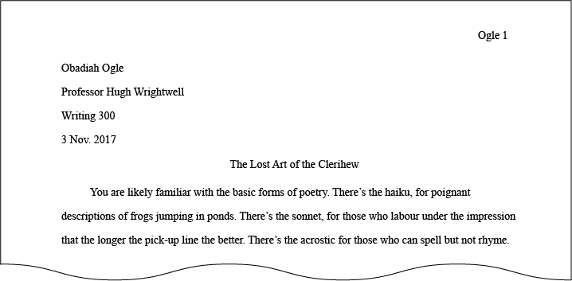
Title is centered. First line of paper is indented.
Your last name and page number should appear on every page.

Purdue Writing Lab. “General Format // Purdue Writing Lab.” Purdue Writing Lab, https://owl.purdue.edu/owl/research_and_citation/mla_style/mla_formatting_and_style_guide/mla_general_format.html.
“The Essay Format: MLA Guidelines.” The Nature of Writing, https://natureofwriting.com/courses/essay-writing/lessons/the-essay-format/topic/the-essay-format-mla/.

Basic Rules for Works Cited
- Begin your Works Cited page on a separate page at the end of your essay/research paper. It should have the same one-inch margins and last name, page number header as the rest of your paper.
- Label the page Works Cited (do not italicize the words Works Cited or put them in quotation marks) and center the words Works Cited at the top of the page.
  - Only the title should be centered. The citation entries themselves should be aligned with the left margin.
- Double space all citations, but do not skip spaces between entries.
- Indent the second and subsequent lines of citations by 0.5 inches using the TAB key to create a hanging indent.
- Entries are listed alphabetically by the author's last name (or, for entire edited collections, editor names). Author names are written with the last name first, then the first name, and then the middle name of middle initial when needed.
- List page numbers of sources efficiently, when needed. If you refer to a journal article that appeared on pages 225 through 250, list the page numbers on your Works Cited page as pp. 225-250. If the excerpt is spans multiple pages, use “pp.” Note that MLA style uses a hyphen in a span of pages.
- If only one page of a print source is used, mark it with the abbreviation “p.” before the page number (e.g., p.157). If a span of pages is used, mark it with the abbreviation “pp.” before the page number (e.g., pp.157-168).
- If you're citing an article or a publication that was originally issued in print form but that you retrieved from an online database, you should type the online database name in italics. You do not need to provide subscription information in addition to the database name.
- For online sources, you should include a location to show readers where you found the source. Many scholarly databases use a DOI (digital object identifier). Use a DOI in your citation if you can; otherwise use a URL. Delete “http://” from URLs. The DOI or URL is usually the last element in a citation and should be followed by a period.
- All works cited entries end with a period.
- Capitalize each word in the titles of articles, books, etc., but do not capitalize articles (the, an), prepositions, or conjunctions unless one is the first word of the title or subtitle: Gone with the Wind, The Art of War, There Is Nothing Left to Lose.
- Use italics (instead of underlining) for titles of larger works (books, magazines) and quotation marks for titles of shorter works (poems, articles)

Example Works Cited Ogle 6
Your last name and the page # are included on every page, including the Works Cited.

Alphabetical order by last name.
Title is centered. Everything remains double spaced.
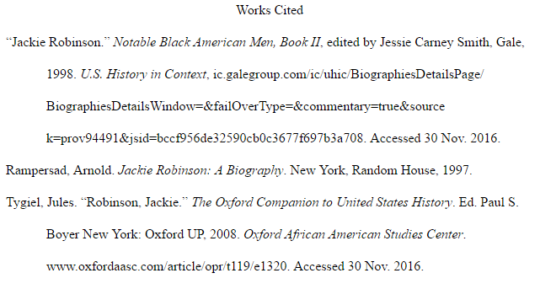

Indent the second and subsequent lines of citations.

How to Cite in the Works Cited
Single Author
Last Name, First Name. Title of Book. City of Publication, Publisher, Publication Date.
Gleick, James. Chaos: Making a New Science. Penguin, 1987.
More Than One Author
Last Name, First Name and First Name Last Name. Title of Book. City of Publication, Publisher, Publication Date.
Gillespie, Paula, and Neal Lerner. The Allyn and Bacon Guide to Peer Tutoring. Allyn and Bacon, 2000.
No/Unknown Author
Encyclopedia of Indiana. Somerset, 1993.
Anthology or Collection
Hill, Charles A., and Marguerite Helmers, editors. Defining Rhetoric. Lawrence Erlbaum Associates, 2004.
Work in an Anthology, Reference or Collection
Last name, First name. "Title of Essay." Title of Collection, edited by Editor's Name(s), Publisher, Year, Page range of entry.
Harris, Muriel. "Talk to Me: Engaging Reluctant Writers." A Tutor's Guide: Helping Writers One to One, edited by Ben Rafoth, Heinemann, 2000, pp. 24-34.
Poems or Short Stories
Burns, Robert. "Red, Red Rose." 100 Best-Loved Poems, edited by Philip Smith, Dover, 1995, p. 26.

Article in a Reference Book (e.g. Encyclopedias, Dictionaries)

"Ideology." The American Heritage Dictionary, 3rd ed., Dell, 1997, p. 369.

An Introduction, Preface, Foreword, or Afterword

Farrell, Thomas B. Introduction. Norms of Rhetorical Culture, by Farrell, Yale UP, 1993, pp. 1-13.

The Bible

The Bible. Authorized King James Version, Oxford UP, 1998.

A Government Publication

United States, Congress, Senate, Committee on Energy and Natural Resources. Hearing on the Geopolitics of Oil. Government Printing Office, 2007. 110th Congress, 1st session, Senate Report 111-8.

A Pamphlet

Your Rights Under California Welfare Programs. California Department of Social Services, 2007.

Last Name, First Name (if author found). “Article Name.” Title of webpage or website, URL. Accessed date.

Purdue Writing Lab. “MLA Works Cited Page: Basic Format // Purdue Writing Lab.” Purdue Writing Lab, https://owl.purdue.edu/owl/research_and_citation/mla_style/mla_formatting_and_style_guide/mla_works_cited_page_basic_format.html.

