Orillia Secondary School Library

APA Cheat Sheet #1

This sheet will assist you with integrating in-text citations
→ Basic style of using APA in an essay or report
→ Paraphrasing/Summarizing
→ Short quotations
→ Long quotations

Using APA the basics
In-text citation capitalization, quotes, and italics/underlining
- Always capitalize proper nouns, including author names and initials: D. Jones.
- If you refer to the title of a source within your paper, capitalize all words that are four letters long or greater within the title of a source: Permanence and Change. Exceptions apply to short words that are verbs, nouns, pronouns, adjectives, and adverbs: Writing New Media, There is Nothing Left to Lose.
(Note: in your Reference list, only the first word of a title will be capitalized: Writing new media.)
- When capitalizing titles, capitalize both words in a hyphenated compound word: Natural-Born Cyborgs.
- Capitalize the first word after a dash or colon: "Defining Film Rhetoric: The Case of Hitchcock's Vertigo."
- Italicize the titles of longer works such as books, edited collections, movies, television series, documentaries, or albums: The Closing of the American Mind; The Wizard of Oz; Friends.

Summarizing or Paraphrasing

If you are summarizing or paraphrasing an idea from another work, you only have to make reference to the author and year of publication in your in-text reference, APA guidelines encourage you to also provide the page number (although it is not required.)
Examples:
According to Jones (1998), APA style is a difficult citation format for first-time learners.
APA style is a difficult citation format for first-time learners (Jones, 1998, p. 199).

Short quotations
If you are directly quoting from a work, you will need to include the author, year of publication, and page number. Introduce the quotation with a signal phrase that includes the author's last name followed by the date of publication in parentheses.
Examples:
According to Jones (1998), "Students often had difficulty using APA style, especially when it was their first time" (p. 199).
Jones (1998) found "students often had difficulty using APA style" (p. 199); what implications does this have for teachers?

Long quotations
Place direct quotations that are 40 words or longer (this includes a, the, and …) in a free-standing block of typewritten lines and omit quotation marks. Start the quotation on a new line, indented 1/2 inch from the left margin by using the TAB key. Type the entire quotation on the new margin, and indent the first line of any subsequent paragraph within the quotation 1/2 inch from the new margin. Maintain double-spacing throughout. The parenthetical citation should come after the closing punctuation mark.
Example:
Jones's (1998) study found the following:
Students often had difficulty using APA style, especially when it was their first time citing sources. This difficulty could be attributed to the fact that many students failed to purchase a style manual or to ask their teacher for help. (p. 199)
Notice the indent when the quote is first started. There are also no quotation marks for the quote.

Purdue Writing Lab. (n.d.). In-Text Citations: The Basics // Purdue Writing Lab. Retrieved from https://owl.purdue.edu/owl/research_and_citation/apa_style/apa_formatting_and_style_guide/in_text_citations_the_basics.html
Orillia Secondary School Library

APA Cheat Sheet- Reference List #2

This sheet will assist you with your APA style Reference List

Basic Rules for Reference List
- All lines after the first line of each entry in your reference list should be indented one-half inch from the left margin. Use tab to create this indentation.
- Authors' names are inverted (last name first); give the last name and initials for all authors of a particular work for up to and including seven authors.
- Reference list entries should be alphabetized by the last name of the first author of each work.
- For multiple articles by the same author, or authors listed in the same order, list the entries in chronological order, from earliest to most recent.
- Present the journal title in full.
- Maintain the punctuation and capitalization that is used by the journal in its title.
  - For example: ReCALL not RECALL or Knowledge Management Research & Practice not Knowledge Management Research and Practice.
- Capitalize all major words in journal titles. When referring to the titles of books, chapters, articles, or webpages, capitalize only the first letter of the first word of a title and subtitle, the first word after a colon or a dash in the title, and proper nouns.
  - Note that the distinction here is based on the type of source being cited. Academic journal titles have all major words capitalized, while other sources' titles do not.
- Italicize titles of longer works such as books and journals.
- Do not italicize, underline, or put quotes around the titles of shorter works such as journal articles or essays in edited collections.
- Please note: While the APA manual provides many examples of how to cite common types of sources, it does not provide rules on how to cite all types of sources. Therefore, if you have a source that APA does not include, APA suggests that you find the example that is most similar to your source and use that format. For more information, see page 193 of the Publication Manual of the American Psychological Association, 6th ed., 2nd printing.

Example Reference List
The page # and the title of the project is in the heading
Notice the indentation on the second line and also be aware that it is double spaced.
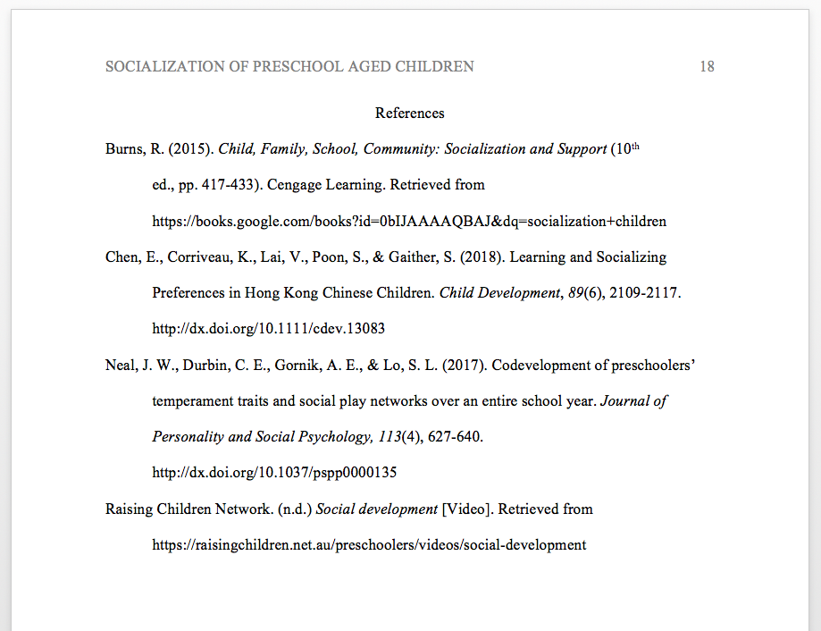
Alphabetic Order

How to Cite in the Reference List

