Explain Everything

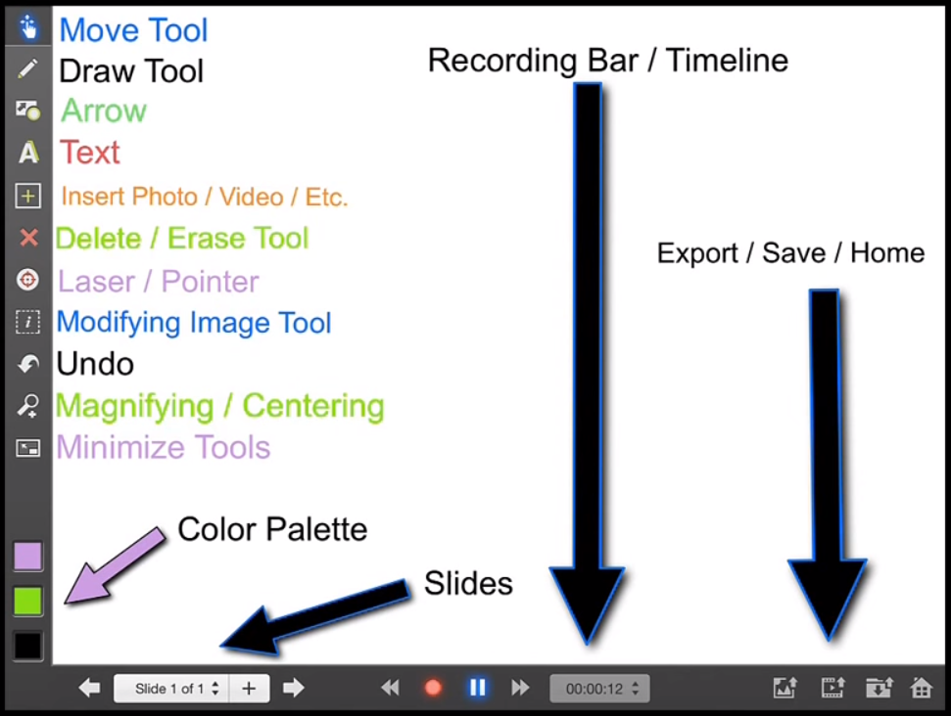

https://www.youtube.com/watch?v=9yvA4bzfrl4 – Overview of Explain Everything

https://www.youtube.com/watch?v=q0qZucJ_V3w – How to Record using Explain Everything

